Hancock County Arts
Salutes
TEACHERS AND STUDENTS

It is time to be back in our routines.
So all is calm in the world for a while.

Thank you to all the teachers.
____________________________________________

- AUGUST 12 2nd Friday-Chocolate Walk/Art War/Garden Art
- Hi-Lighted Member
- August AT THE GALLERY
- Classes/Studio Time in Hancock County
- September AT THE GALLERY
- Save the Date - Diamonds and Denim Gala, October 22
- A “Pause for Words"
- Vawter People’s Choice Awarded
- Thank you
- Just a Note!
____________________________________________

2nd Fridays in Greenfield

August brings the Chocolate Walk. Pre-Sale Ticket can be purchased through August 11.
AUGUST 12, 2nd Friday, we are a City of Greenfield Chamber Chocolate Walk Participant!
YUM.
Eating chocolate at least once a week is linked with a reduced risk of heart disease, according to research published today in the European Journal of Preventive Cardiology, a journal of the European Society of Cardiology (ESC).¹

We will see you August 12!

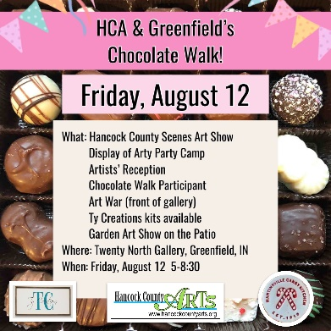
____________________________________________

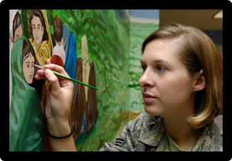
ART WAR – August 12, 2022
Watch artists paint and vote for your favorite so the artist receives Special Chocolate – they might share! Each hour from 5 till 8, artists will be in front of the Gallery for all to see.

Stop by, cheer the artists on and drop their ballots in the ballot box on their way into the gallery.

And then look out back!!! An Garden Art Show - August 12, 2022
We’ll fill our deck space gardens and lattice walls with your fun pieces. Display will include glass, metal, wood - anything we can display outdoors. Dazzling our Chocolate Walk visitors by showing them that art carries over into outdoor spaces. Prize for Best Entry.
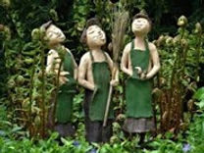
____________________________________________

Member Highlight – August, 2022
We would like to introduce or re-introduce all of you to Tattoos In Time. YOUR INFO HERE!!!
____________________________________________

AUGUST, At the Gallery
Hancock County Scenes
Come see artwork of Hancock County: the streets, the farms, the people, etc.
The show will run through August 27th, a lot of people visiting during Chocolate Walk and Art War on the second Friday!
Any questions, contact hancockcountyarts@gmail.com
People’s Choice Awarded at this exhibit
____________________________________________

Classes/Studio Time Throughout Hancock County

Time to register!

AT our TwentyNorth Gallery/Register Online www.hancockcountyarts.org for classes, questions contact hancockcountyarts@gmail.com

Open Fiber August moved to Second Thursday, Aug 11, see you then!

Open Studio Each Tuesday, 9 – 12

Still Life Each Thursday 1 – 4

AT The Gilded Nest 12 W. Main Street, 317.318.2191 Call to register for each
Every Monday 6pm: watercolor class with Michelle Kimberlin $35
Every Wednesday 4pm: Kid's class with Michelle Kimberlin $35
August, David Kearns with Pottery Sessions

AT Greenfield Parks Department Register: https://parks.greenfieldin.org/
____________________________________________

SEPTEMBER, At the Gallery
Sandy Hall and Mary Cork
Lilly Teacher’s Creativity Grant Travel Exhibit
Wonderful show of their travels.

SEPT 17

Annual Chalkfest in the Living Alley.
AND inviting Businesses to Chalk their Walks!
See all the artwork throughout Hancock County!
Join in and Chalk!

American Legion 5th Annual Four Post Bed Race on North Street
https://www.facebook.com/groups/251376318234006/
Get your team together!
Sign up on their Facebook Page

____________________________________________
Diamonds and Denim Gala
Online Auction for the Arts
October 22, 2022
SAVE THE DATE
Bid on tickets for “Straight No Chaser”
December Performance
Bidding begins September 26th!
Watch for more Information
At Bradley Hall Event Center
www.biddingforgood.com/HANCOCKCOUNTYARTS
____________________________________________

A "Pause for Words"








  !"
#!
Thwap!

There is no
greater silence
than the silence
of a housefly
freshly silenced.

Leah McNaughton Lederman is an author and freelance editor living in Greenfield with her husband and an assortment of children, cats, and dogs. Keep up with her on her website: www.leahlederman.wordpress.com.
____________________________________________

Will Vawter Exhibit
2022 People’s Choice Award

Mariann Hamilton was awarded People’s Choice this year for her pastel of “Cabo”.

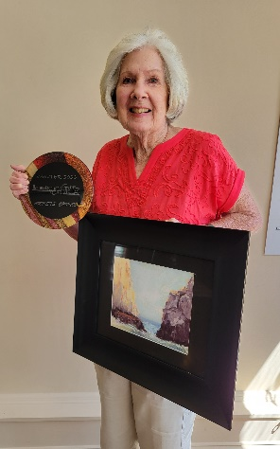

THANK YOU
Mary Lee Griffin
Born on Halloween in 1930 in Dale, Indiana, she died December 15, 2021, at age 91. Mary Lee loved reading, and doing art of all kinds - painting, making jewelry, stained glass, and much more. Mary Lee grew up in Indianapolis, lived all over the country and even in Sweden for a couple years. She came back to Indiana in 1990. Moving to Greenfield in 2013. Mary Lee’s family came to Hancock County Arts and asked if we could use the art supplies which were left when she passed. We said “Yes, always.” Those supplies went to an elementary school in Hancock County. We can not thank Mary Lee Griffin’s family enough for their generosity. Sincerely, Hancock County Arts Council.
____________________________________________

Just a Note!
Hancock County Arts is looking for members with vision. We are at a point to make moves to increase our reach and we need planners, partners, and visionaries to help us!
If you want to be a part of some exciting art and culture creativity and growth, let us know.
Contact Alice Hedden, at Hancockcountyarts@gmail.com
Thank you.
____________________________________________

Our Mission
Hancock County Arts will provide leadership for the creative community
by encouraging, celebrating, and promoting arts and culture throughout Hancock County.
Open Wednesdays, Thursdays and Saturdays
11 till 2
Open for private showings, contact us.
hancockcountyarts@gmail.com
www.hancockcountyarts.org
20 N State Street
Greenfield, IN
317.967.2461
BE PART OF THE ARTS!

