Bruce Allan Neville was born in Rhode Island and studied at the Boston Architectural Center and Wentworth Institute in Boston Massachusetts. Neville moved to Cincinnati, Ohio in 1960 and graduated from the University of Cincinnati in the DAAP program in 1966 receiving a Bachelor of Science in Architecture.
Neville is a signature member of the Ohio Watercolor Society, an Associate member of the American Watercolor Society, and a Signature member of the Cincinnati Art Club. Neville has won numerous awards and honors including the RAM Richmond Art Museum Award of Excellence, CAC Viewpoint Award, Boston Mills Award of Best in Show, and two years Best in Watercolor at Carmel International in Carmel, IN. Neville has extensive teaching experience at the college level at the Cincinnati Art Academy and workshops throughout the Midwest.
Neville’s style and technique were published in the “The Watercolor Technique of 23 International Artist”. My goal is to develop not a style of painting but a way of thinking, interpreting, and being creative. Each painting conveys a unique experience leading the viewer into a new way of seeing and understanding my process.
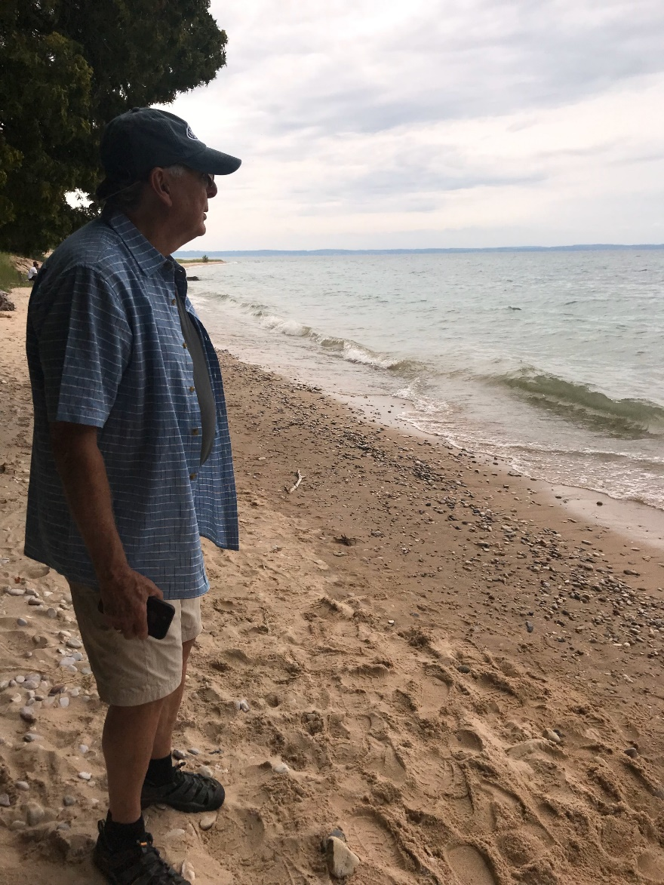
nevillearts@gmail.com
(513) 405-0141

https://www.bruceneville.com/

