Hancock County Arts Salutes
the USA.
“GOD BLESS AMERICA,
Land That I Love, stand beside her and guide her,
through the night with a light from above. …”
Have a Fun and Safe Holiday.



- It is All About 2nd Fridays in Greenfield
- Will Vawter Exhibit through July 16- MOST IMPORTANT DATES
- Member Hi-Light – Why Will Vawter?
- July AT THE GALLERY
- Classes around Hancock County
- Tickets on sale now for “Once Upon a Mattress”
- A Pause for Words"
- AUGUST 12 2nd Friday-Chocolate Walk/Art War/Garden Art
- Just a Note!
____________________________________________

2nd Fridays in Greenfield

Yes, there are quite a few places creating a great atmosphere with the help of Organic Robots, Gilded Nest, Greenfield Chocolates, Hancock County Arts, The Wooden Bear and more are joining each month. As the Friday’s events expand, you will find more and more fun and exciting happenings on 2nd Fridays in Greenfield, IN. Don’t miss out! See you there!
____________________________________________

The 2022 Will Vawter Art Exhibition
Open Wednesdays, Thursdays, 11 AM – 2 PM

Extended hours Saturday, 11 AM – 5 PM

Through July 16

50 Award winning Indiana artists from throughout Indiana

have exhibited their artwork

at our TwentyNorth Gallery in Greenfield.

Be sure to see the exhibit before it ends on July 16.

July 2nd, 1st place winner, Dianna Porter will demonstrate

a watercolor portraiture with a local model at 1 PM.

July 8th will be open during 2nd Friday, 6:30 till 8:30.

Stop in to see the stunning artwork before you dine at one of the nearby restaurants.

July 16th, 2 more artwork demonstrations will take place.

Award Winning, American Impressionist, Mary Ann Davis at 11 AM.

Award Winning, Best of Show winner, Patrick Kluesner at 1 PM and

Most of the artists will be there to chat.

See you there.

____________________________________________

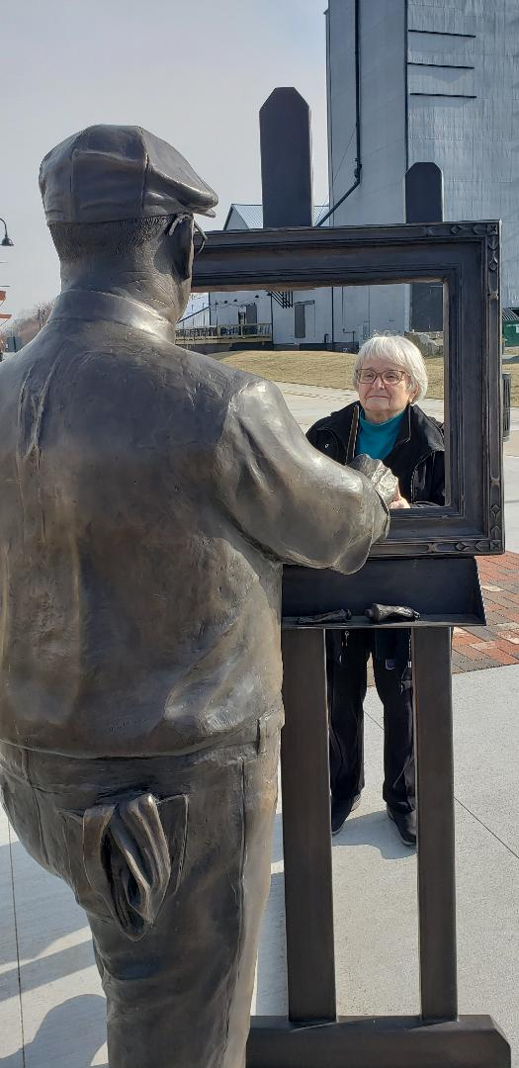
Member Highlight – July 2022
Why Will Vawter?
Hancock County Arts is delighted to introduce or reintroduce you to Will Vawter. The Hancock County Arts Council celebrates the 24th year of our Will Vawter Art Exhibition. We are in Wikipedia!
WILL VAWTER was born on April 13, 1871, in Boone County, West Virginia. He moved with his family to Greenfield, Indiana, at age six. Young Will loved to draw and would frequently fill the pages of his schoolbooks with sketches. Basically, a self -taught artist, Vawter started doing illustrations for the Indianapolis Sentinel in 1891. Soon his work appeared in other newspapers and magazines. Around the same time, another Greenfield native was also making a name for himself as a poet. James Whitcomb Riley, known as the “Hoosier Poet,” was a national bestseller with poems such as “Little Orphant Annie” and “The Raggedy Man.” In 1893, Riley hired Will Vawter as an illustrator. Over the next thirty years, Vawter ’s work appeared in many of Riley’s books.
His illustrations often used local residents as models. His work was widely celebrated and he exhibited at the Hoosier Salon and the Brown County Art Gallery Association where he won prizes in 1925, 1926, 1928, 1930, 1932 and 1935.^{[2]} He was married to Mary Vawter, an accomplished poet and landscape artist. The couple divorced in 1923. Vawter moved to Nashville, Indiana, to join the Brown County Art Colony permanently in 1908. He had two residences in the area, one a studio in town, the other a 57 acres estate about a half mile outside of Nashville. Vawter was a pioneer member of the Brown County Art Gallery Association. There he helped establish what would later be known as the Brown County Art Colony along with other famous Indiana artists, such as, T.C. Steele and Adolph and Ada Shulz. Despite moving to Brown County, Vawter maintained his Greenfield ties. Will Vawter died in 1941 and was laid to rest in Greenfield ’s Park Cemetery.
____________________________________________

JULY AT THE GALLERY

JULY 2, Portrait Demo by Dianna Porter, 1 PM
JULY 8, 2nd Friday
JULY 16, Painting Demo, MaryAnn Davis, 11 AM, Patrick Kluesner 1, PM
____________________________________________

July 20 through July 30
Daydreams and Nightmares
Exhibition By Joy Carter

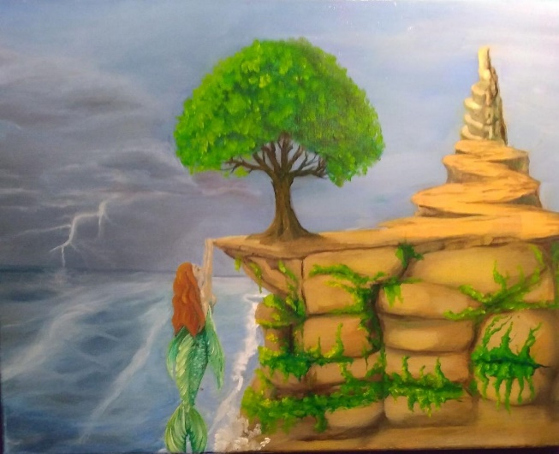
JULY 20, OPEN Daydreams and Nightmares
JULY 22, Meet Joy Carter, Artist’s Reception, 6:30-8:30
JULY 30, Face Artist, Joy Carter, Noon – 2 PM, will be offering sessions for $10. No registration
necessary but come early to reserve your session. Don’t miss this opportunity to meet Joy and
wear one of her famous face art creations.

JULY 29 Garden Lover’s Bouquet Class 6:30-8:30 $35/person, supplies included, ages 10 and up, accompanied by adult.

____________________________________________

Classes Throughout Hancock County

Time to register!

AT our TwentyNorth Gallery/Register Online www.hancockcountyarts.org for classes, questions contact hancockcountyarts@gmail.com

Open Fiber Canceled for July 7 and for August moved to Second Thursday, Aug 11, see you then!

Still Life Each Thursday 1 – 3

Open Studio Each Tuesday, 9 – 12
Classes July 18 – 22.
Pick 3 of the 5 classes for $60
18th Ink on Ceramic Tile Making on Monday
19th Paper Mache Class on Tuesday
20th Weaving Class on Wednesday
21st Painting Class on Thursday
22nd Drawing and completion of Paper Mache Class on Friday

AT The Gilded Nest 12 W. Main Street, 317.318.2191 Call to register for each
Every Monday 6pm: watercolor class with Michelle Kimberlin $35
Every Wednesday 4pm: Kid's class with Michelle Kimberlin $35
July 15, David Kearns will begin Pottery Sessions

AT Greenfield Parks Department Register: https://parks.greenfieldin.org/
Summer Art Camps are here, and registration is open! This summer is going to be a blast! For more information and registration, visit parks.greenfieldin.org or download the Greenfield Parks and Recreation app!
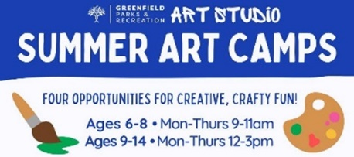 
____________________________________________

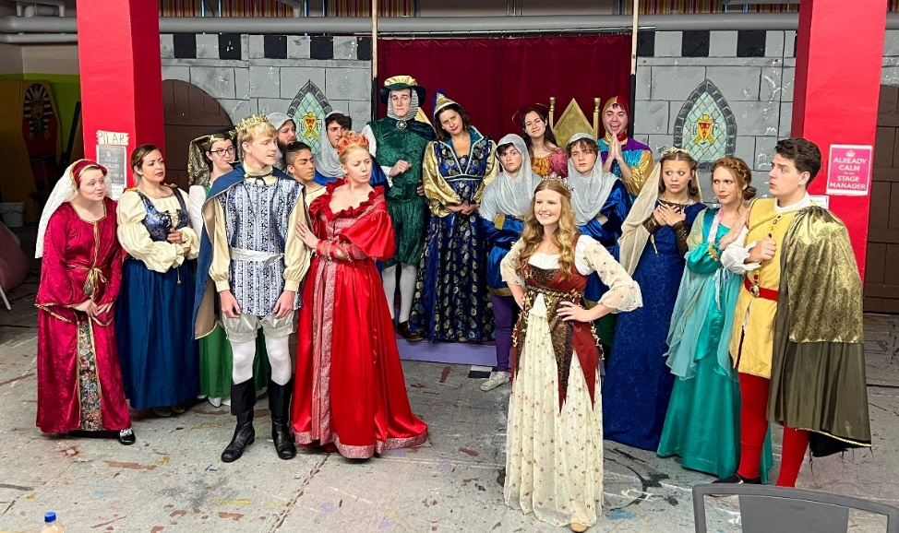
Tickets on sale now for “Once Upon a Mattress”

GREENFIELD – The CrazyLake Acting Company returns to the Ricks Centre for the Arts with “Once Upon a Mattress,” its first summer musical in three years.
“Once Upon a Mattress” is the musical retelling of Hans Christian Andersen’s fairy tale, “The Princess and the Pea.”
Told with a wave of wonderful songs and choreography, this rollicking spin on the classic tale is suitable for the entire family.
Performances are July 8, 9, 10, 15, 16 and 17 at the H.J. Ricks Centre for the Arts, 122 W. Main St in Greenfield.
Friday and Saturday performances are at 7:30 p.m.
Sunday performances are at 2:30 p.m.
Tickets are available in advance for $10 (plus fee) at https://mattressclac.bpt.me
And at Hometown Comics and Games, 1040 N. State St.
Tickets are $12 at the door an hour before showtime.
____________________________________________

A "Pause for Words"
Summer Memories

Take me back to simpler times,
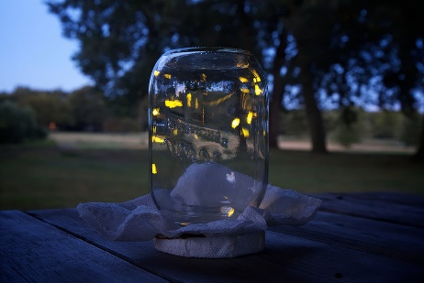
when the stickiest situation was
the banana popsicle melting and
dripping off my elbows.

When pure joy was chasing
those lightning bugs flickering
across our freshly mown lawn, the
smell and taste of honeysuckle.

Lylanne Musselman is an award-winning poet and visual artist, who lives with her cats and creates in Eaton, IN. She is a member of Hancock County Arts, and currently is president of Muncie Artists Guild. Check out her website: Lylanne Musselman – Artist – Poet – Playwright (wordpress.com)

____________________________________________

AUGUST AT THE GALLERY

ARTIST AUGUST CALL OUTS – THREE OPPORTUNITIES
Hancock County Scenes August 1 – Intake for Exhibit through August 27. Prize for People’s Choice.
AUGUST 12, 2nd Friday, we are a City of Greenfield Chamber Chocolate Walk Participant ! YUM.

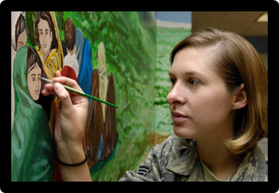
Artist Call Out ART WAR – August 12, 2022 - Looking for contestants to fill these slots:
Art War will begin at 5 – you are invited to paint.
5-6 pm 1. Enter by emailing us at hancockcountyarts@gmail.com - Subject Art War
6-7 pm 2. Pick your favorite time
7-8 pm 3. Chocolate prizes await the winners!
Guests will stop by, cheer the artists on and drop their ballots in the ballot box on their way into the gallery.
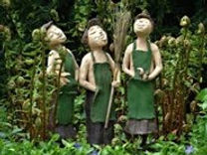
And Garden Art Show - August 12, 2022
Bring us your creative outdoor art to display during this year’s Chocolate Walk night. We’ll fill our deck space gardens and lattice walls with your fun pieces. Display will include glass, metal, wood - anything we can display outdoors. Let’s dazzle our Chocolate Walk visitors by showing them that art carries over into outdoor spaces. Space is limited so reserve your spot now. Prize for Best Entry.

____________________________________________

Just a Note!
$10,000 Fellowship through Indiana Arts Council
What would you do if you were given $10,000 to go in search of creative inspiration? Central Indiana artists and nonprofit arts & culture administrators are invited to apply for the 40 - $10,000
2022-2023 Creative Renewal Arts Fellowship program.
Applications are open until July 17, 2022.
https://indyarts.org/grants/grants-for-individuals/creative-renewal-arts-fellowship
____________________________________________

Just a Note!
Hancock County Arts is looking for members with vision. We are at a point to make moves to increase our reach and we need planners, partners, and visionaries to help push us over that edge!
If you want to be a part of some exciting art creativity and growth, let us know.
Contact Alice Hedden, President, at Hancockcountyarts@gmail.com

____________________________________________

Our Mission
Hancock County Arts will provide leadership for the creative community
by encouraging, celebrating, and promoting arts and culture throughout Hancock County.
Open Wednesdays, Thursdays and Saturdays
11 till 2
Open for private showing, contact us.
hancockcountyarts@gmail.com
www.hancockcountyarts.org
20 N State Street
Greenfield, IN
317.967.2461
BE PART OF THE ARTS!

